\*\*Day 4 - Dynamic Frontend Components - [E-Commerce Clothing Website]\*\*

\*\*1. Functional Deliverables:\*\*

- \*\*Product Listing Page:\*\*

![Screenshot of product listing page with dynamic data]

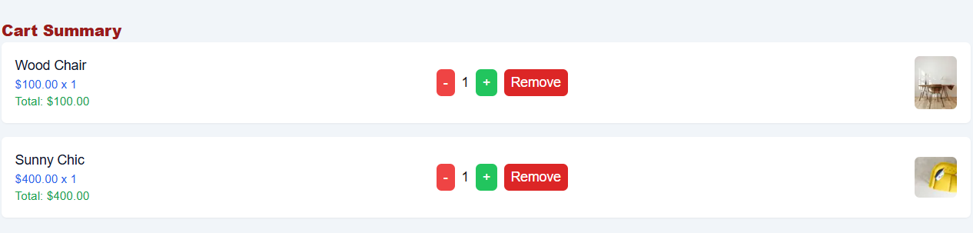

- Displays products in a grid layout with fields like name, price, image, and stock status.

- \*\*Product Detail Page:\*\*

![Screenshot of individual product detail page]

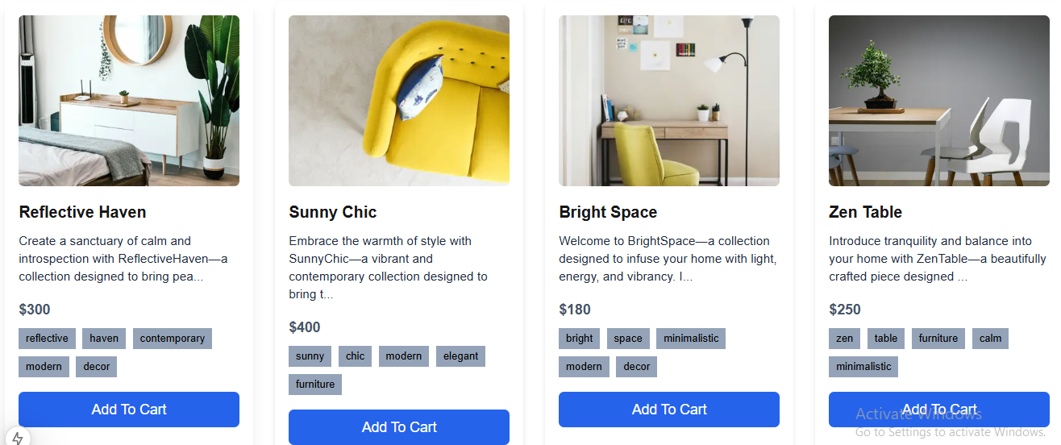

- Dynamic routing implemented for individual product pages with detailed fields like description, price, and available sizes/colors.

- \*\*Additional Features:\*\*

- Pagination, related products, and responsive design implemented.

\*\*2. Code Deliverables:\*\*

- \*\*ProductCard Component:\*\*

```javascript

const ProductCard = ({ product }) => (

<div className="product-card">

<img src={product.image} alt={product.name} />

<h3>{product.name}</h3>

<p>${product.price}</p>

<p>{product.stockStatus}</p>

</div>

);

```

- \*\*ProductList Component:\*\*

```javascript

const ProductList = ({ products }) => (

<div className="product-list">

{products.map((product) => (

<ProductCard key={product.id} product={product} />

))}

</div>

);

```

- \*\*SearchBar Component:\*\*

```javascript

const SearchBar = ({ onSearch }) => (

<input

type="text"

placeholder="Search products..."

onChange={(e) => onSearch(e.target.value)}

/>

);

```

\*\*3. Documentation:\*\*

- \*\*Steps Taken:\*\*

- Connected Next.js project to Sanity CMS and tested data fetching.

- Built reusable components like `ProductCard`, `ProductList`, and `SearchBar`.

- Implemented dynamic routing for product detail pages.

- Added category filters, pagination, and search functionality.

- \*\*Challenges Faced:\*\*

- Ensuring responsive design across devices.

- Debugging API integration issues.

- \*\*Solutions Implemented:\*\*

- Used Tailwind CSS for responsive styling.

- Logged API errors and validated data before rendering.

- \*\*Best Practices:\*\*

- Modular component design for reusability.

- State management using React hooks.

- Responsive and user-friendly UI.

\*\*4. Repository Submission:\*\*

- All files uploaded to GitHub under a well-structured folder hierarchy.

\*\*Checklist for Day 4:\*\*

- \*\*Frontend Component Development:\*\* ✔

- \*\*Styling and Responsiveness:\*\* ✔

- \*\*Code Quality:\*\* ✔

- \*\*Documentation and Submission:\*\* ✔

- \*\*Final Review:\*\* ✔

\*\*Conclusion:\*\*

All tasks for Day 4 have been completed successfully. The frontend components are dynamic, reusable, and responsive, ensuring a professional and scalable marketplace UI. Documentation and code quality adhere to best practices.